## For the first iteration (without tuning)

$∆$ P $∆$ Q

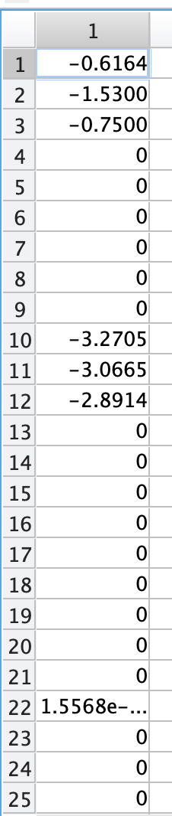

$P_{1}$ $Q_{1}$

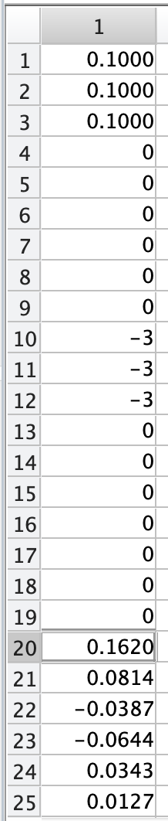

Second iteration, no feasible solution

## For the first iteration (with tuning, $α=0.1$)

$∆$ P $∆$ Q

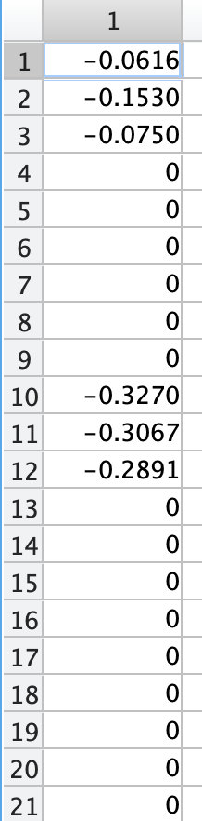

$P_{1}$ $Q_{1}$

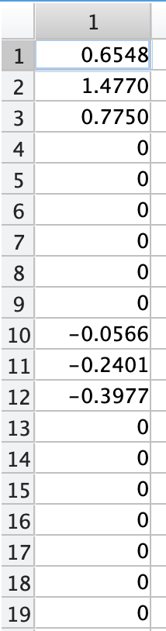

Second iteration, no feasible solution

## For the first iteration (with tuning, $α=0.3$)

$P_{1}$ $Q_{1}$

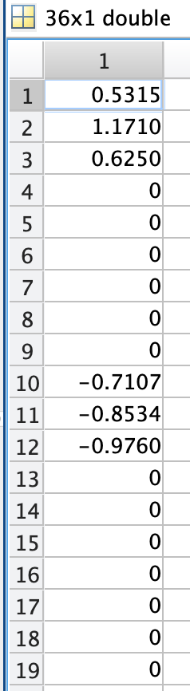

Second iteration, no feasible solution

## For the first iteration (with tuning, $α=0.5$)

$P_{1}$ $Q_{1}$

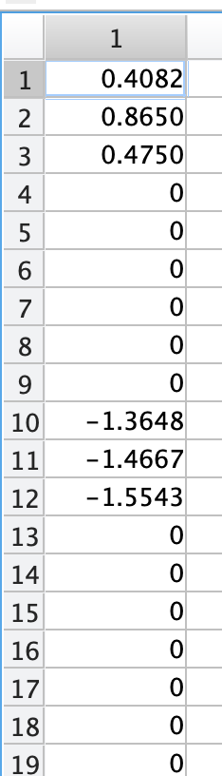

Second iteration, no feasible solution

## For the first iteration (with tuning, )